**Soil Farming Agent: Project Report**

**1. Project Title**

**Soil Farming Agent: An Integrated Web Solution for Smart Agriculture**

**2. Abstract**

Agriculture remains a cornerstone of our economy, yet many farmers face difficulties in accessing real-time soil insights and reliable crop guidance. This project report outlines the “Soil Farming Agent”—a web-based platform developed to bridge this gap. By leveraging Firebase for seamless backend support and modern web technologies for an intuitive user experience, the platform enables farmers to evaluate soil quality, receive crop recommendations, and connect with reputable distributors. The result is a practical tool that promotes efficient agricultural practices and sustainable land management.

**3. Introduction**

Good soil health is fundamental for successful crop yields, but traditional soil assessment methods are often cumbersome and outdated. Recognizing this need, the Soil Farming Agent was conceived to digitize soil management and streamline the process of obtaining crop suggestions. Designed with both farmers and administrators in mind, the solution integrates a secure login feature, real-time database connectivity, and user-friendly dashboards—making advanced soil and crop knowledge accessible from any device.

**4. Objectives**

* Facilitate immediate, centralized management of soil and crop information.
* Empower farmers with evidence-based crop recommendations.
* Enable agricultural administrators to supervise soil and distributor records efficiently.
* Foster sustainable agricultural practices through informed decision-making.

**5. System Analysis**

**5.1 Existing System**

Current approaches to soil record-keeping are often manual and fragmented. Farmers may not have quick access to current soil or crop data and frequently struggle to connect with verified product distributors.

**5.2 Proposed System**

The Soil Farming Agent addresses these challenges with a secure, mobile-responsive platform:

* Instant access to soil and crop data.
* Real-time updates via Firebase Firestore.
* Role-based interfaces for users and admins.
* An easy process for linking with soil distributors.
* Admin oversight of platform-wide user and soil activity.

**6. System Design**

**6.1 Architecture**

* **Frontend:** Built with HTML5, CSS3, and JavaScript, emphasizing clear navigation and accessibility.
* **Backend:** Supported by Google Firebase Authentication and Firestore Database.

**6.2 Module Overview**

**Admin Module**

* Login/Registration (secure authentication for admins)
* Adding and updating soil types
* Registering distributor details
* Monitoring user interactions and soil selections

**User Module**

* Login/Registration (secure authentication for farmers)
* Browsing available soil types
* Registering soil selections
* Receiving crop recommendations tailored to selected soils

**6.3 Data Flow**

1. Users and admins access the platform via their browsers.
2. After authentication, admins configure soil and distributor databases.
3. Users browse soils, save their selections, and receive recommendations.
4. Admins monitor platform activity in real time.

**7. Implementation**

**7.1 Technologies Used**

* **HTML5 & CSS3:** Ensuring modern, visually appealing, and responsive layouts.
* **JavaScript (ES6):** Powering interactivity and handling API integration.
* **Firebase:** Managing authentication and real-time NoSQL database functions.
* **Icons8:** Providing engaging icons for visual clarity.
* **Deployment:** Compatible with Firebase Hosting and other static web servers.

**7.2 Key Features/Screens**

* **Landing Page:** Project introduction and navigation.
* **Registration/Login:** Separate flows for users and admins.
* **Admin Dashboard:** Tools for database management and oversight.
* **User Dashboard:** Simple soil selection and instant crop suggestions.

**8. Database Design**

* **soilDetails Collection:** Stores type, distributor info, location, phone, timestamp.
* **userSelections Collection:** Links user ID, email, selected soil, and timestamp.
* **Security Rules:** Strict access control—admins can write soil data, all authenticated users can submit selections, and all reads require user authentication.

**9. Testing & Validation**

Testing was done across various devices and browsers to ensure accessibility, data security, and correctness. Both the admin and user workflows were validated, with attention given to authentication and accurate data display. The system performed reliably under normal use and showed excellent real-time data synchronization.

**10. Results**

The Soil Farming Agent is fully operational. Farmers can log in, select soils, and gain meaningful crop recommendations quickly. Administrative users can efficiently manage data, and all users benefit from real-time updates—no software installation required. Responsive design guarantees usability across smartphones, tablets, and desktops.

**11. Benefits & Applications**

* Streamlined access to soil and crop guidance for all stakeholders.
* Greater administrative control and transparency.
* Promotes sustainable agriculture and can be adapted to include future features such as AI-driven recommendations.
* Strong foundation for expansion, including analytics, local language support, and geolocation integration.

**12. Limitations & Future Enhancements**

* Current crop suggestions are based on basic preset rules; incorporating an AI recommendation engine would increase accuracy.
* Platform requires an active internet connection.
* Distributor list accuracy depends on admin diligence.
* Enhancement potential: GPS/location tools, multi-language support, and automated crop-matching algorithms.

**13. Conclusion**

Through modern web technologies and a user-centric approach, the Soil Farming Agent demonstrates how digital solutions can improve agricultural efficiency and resource management. The platform provides real-time, secure soil and crop information—empowering both farmers and administrators for better agricultural outcomes.

**14. References**

* Firebase Documentation
* W3C Standards for HTML, CSS, and JavaScript
* Icons8 Open License (for visual assets)
* Project development notes and codebase

**15. Appendix**

**15.1 Screenshots**

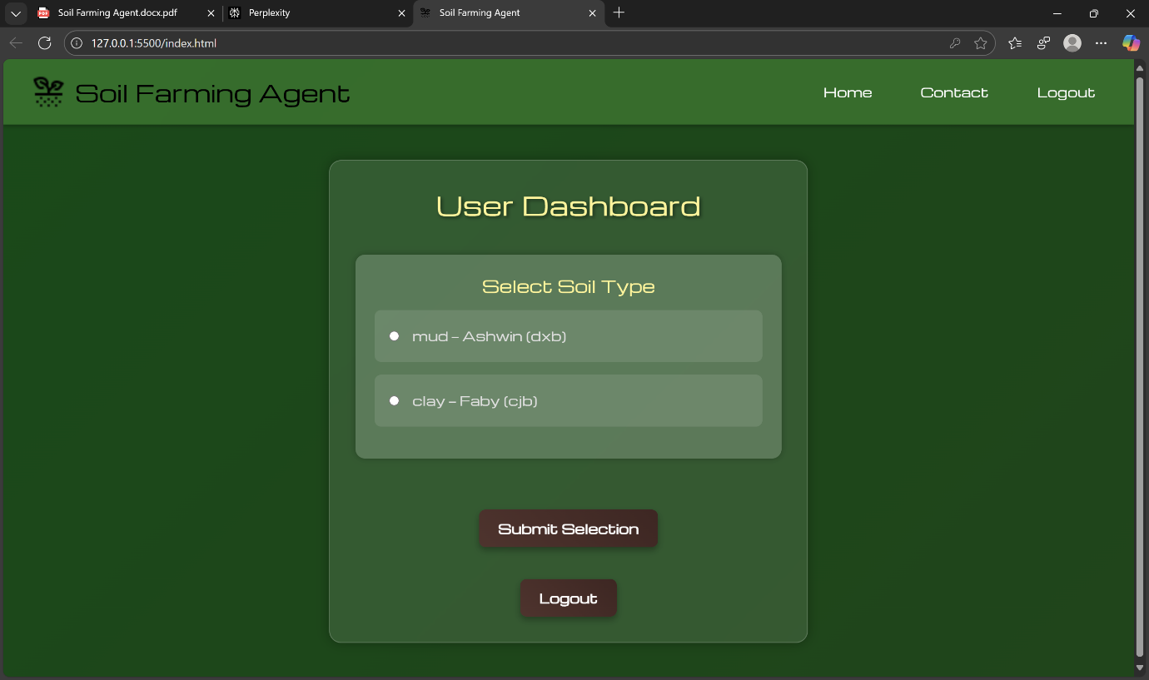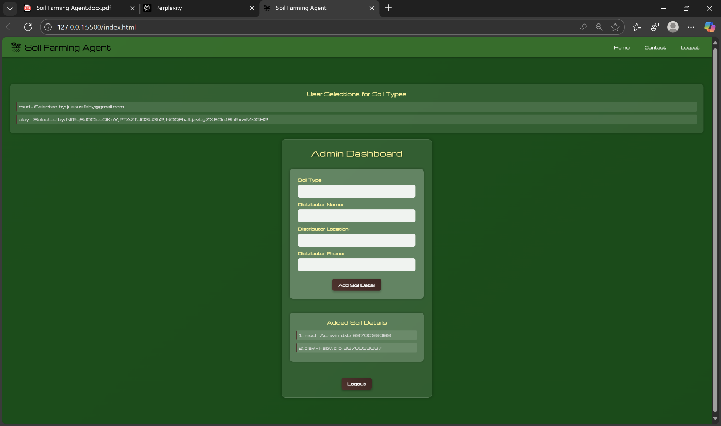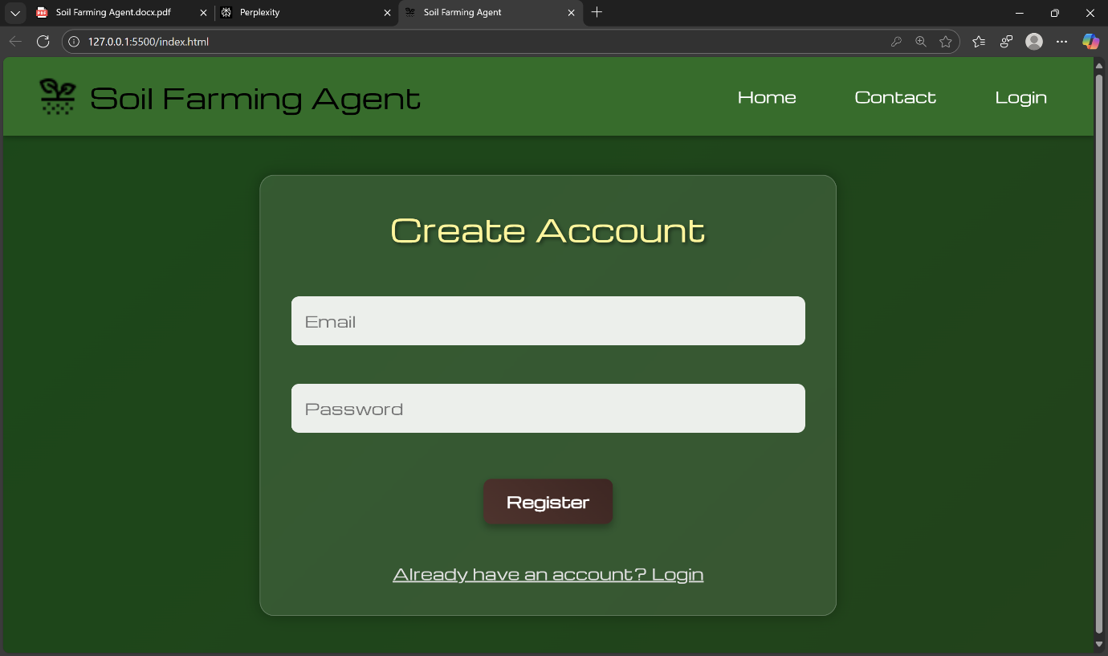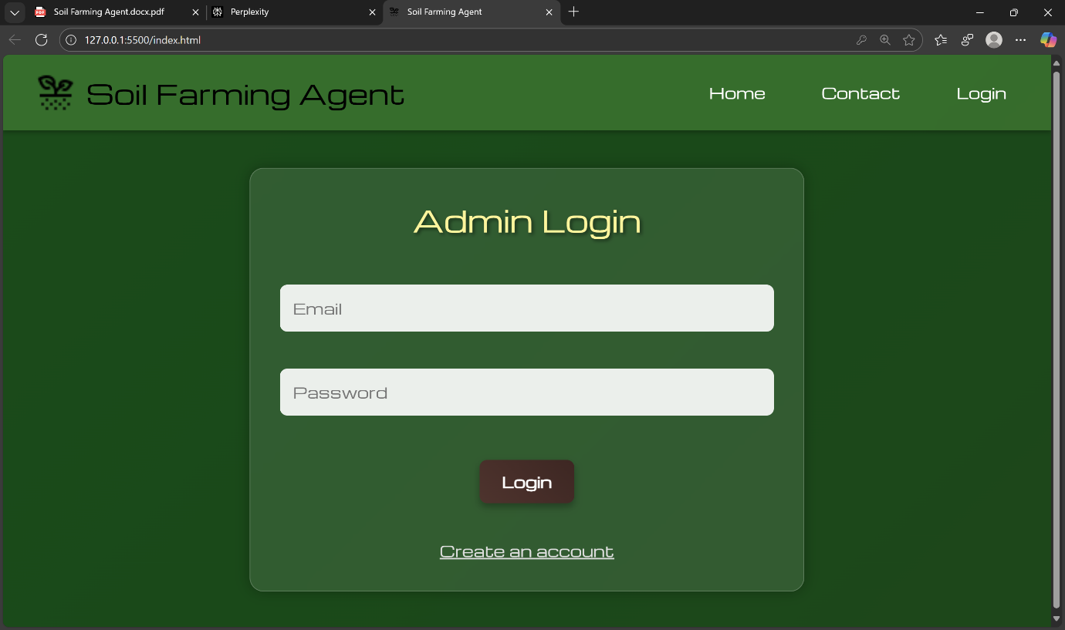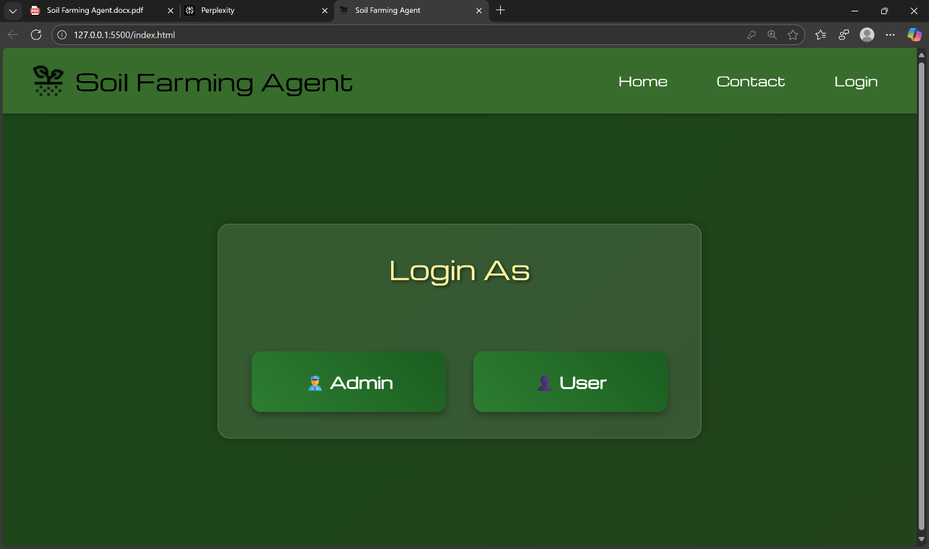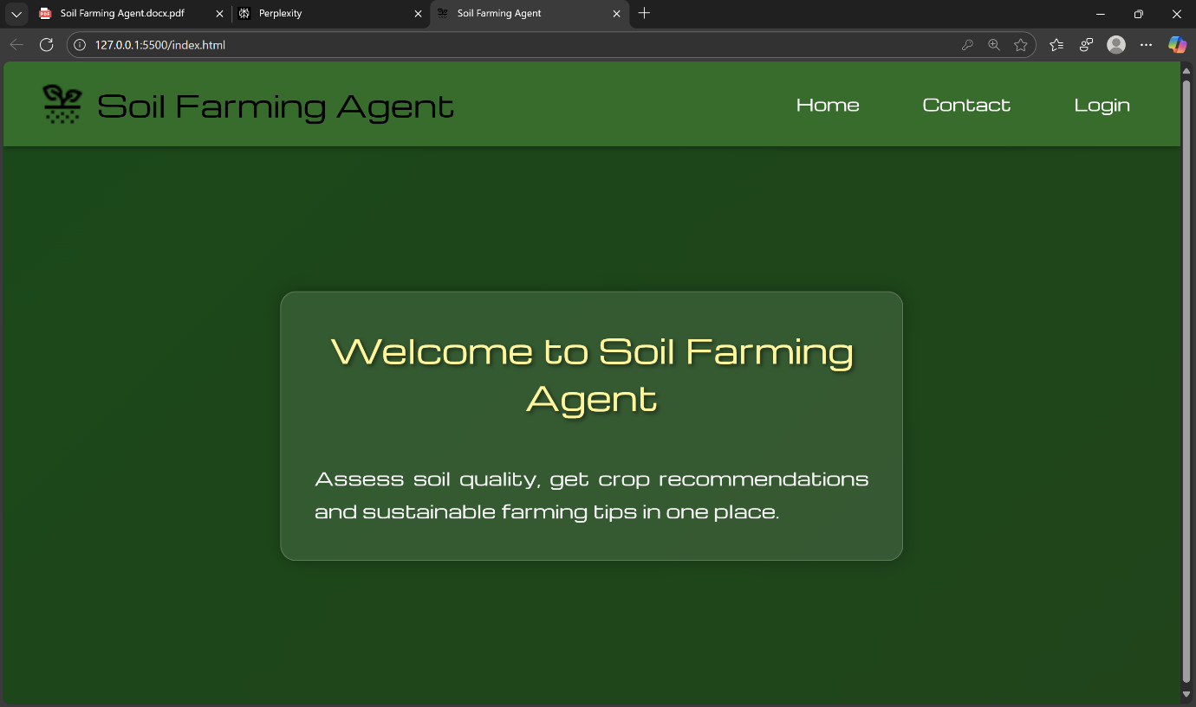

**15.2 Contact Information**

Prepared by: Justus Faby  
Email: [justusfaby@gmail.com](mailto:justusfaby@gmail.com)  
Phone: +91 88700 99067  
Address: 18/5, Royal Garden, Kuniyamuthur, Coimbatore, Tamil Nadu, India